Simple code:

#include <stdio.h>

void add() {

int x = 10;

static int y = 20;

x++;

y++;

printf("%d\n", x);

printf("%d\n", y);

}

int main() {

add();

add();

add();

return 0;

}

Task001 Java:

class Main {

public static void main(String[] args) {

System.out.println("Hello how are you");

System.out.println("are yout there");

}

}

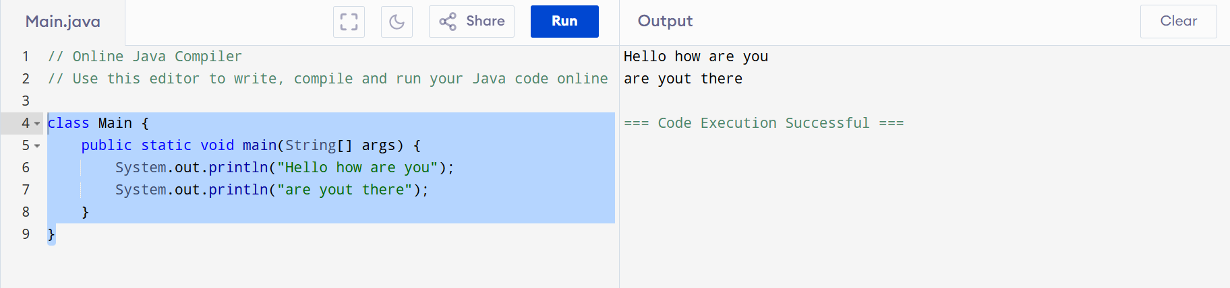

Task 002 an d 003 Java:

class Main {

//Method to add two numbers and display the result

public static void add() {

int a = 7;

int b = 6;

int sum = a+b;

System.out.println("Sum of a and b "+a+" "+b+sum);

}

public static void main(String[] args) {

// Call the add method 3 times

add();

add();

add();

}

}

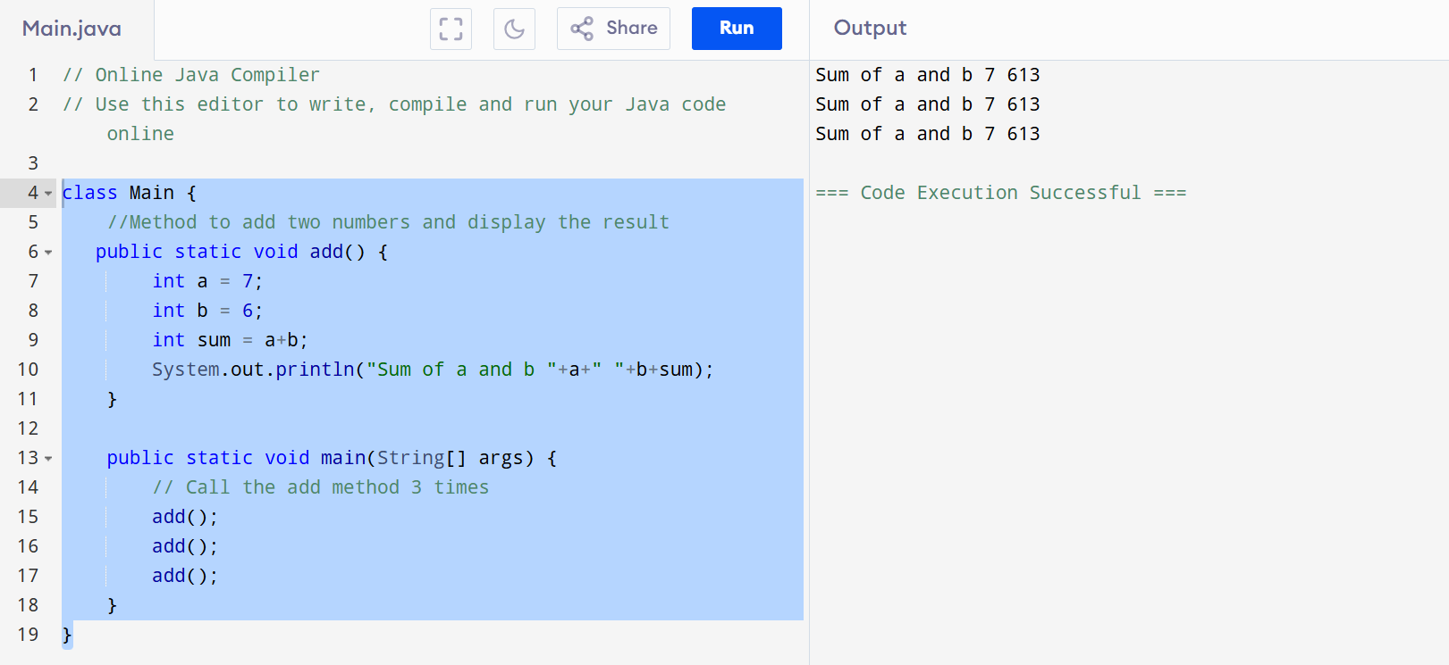

Task 004

class SwapNumbers {

public static void main(String[] args) {

int a = 2;

int b = 5;

System.out.println("Before swap");

System.out.println("a=" + a + "b=" + b);

//Swapping logic

int temp = a;

a = b;

b = temp;

System.out.println("After swap");

System.out.println("a=" + a + " b=" + b);

}

}

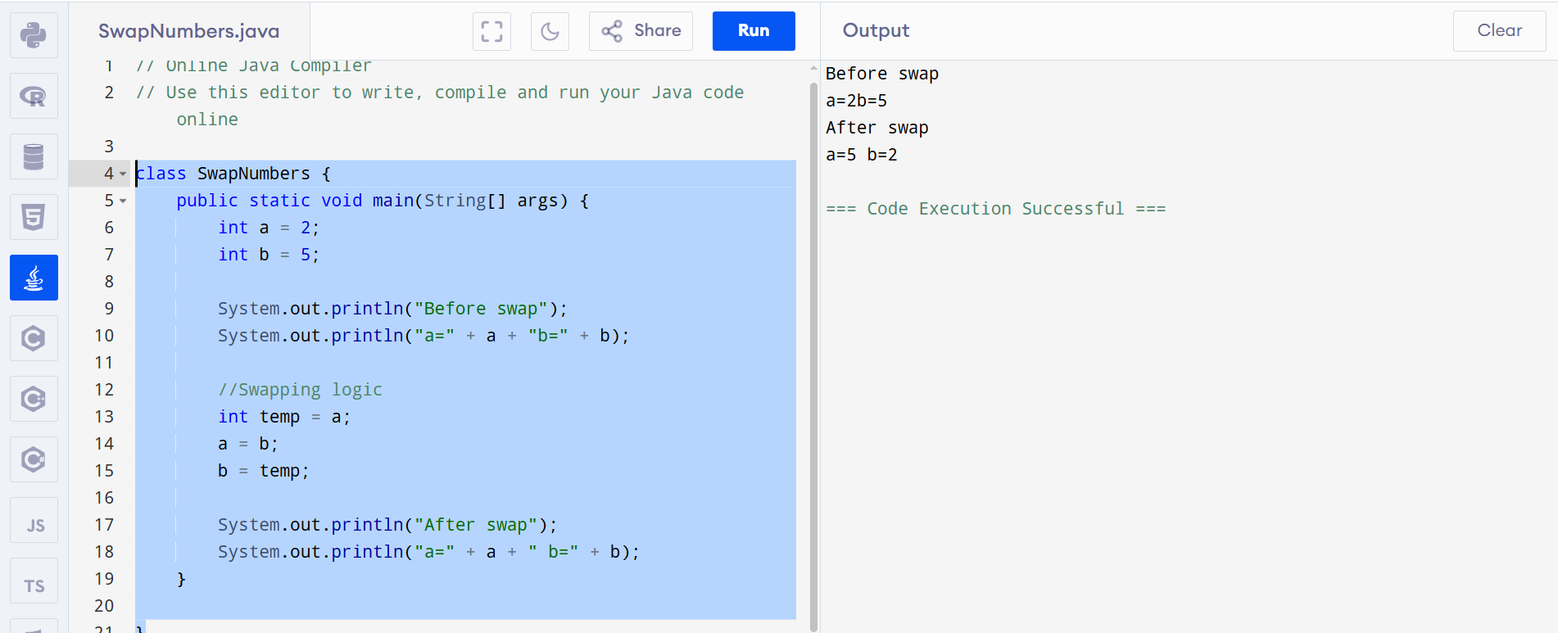

Task 5:

class Operations {

public static void main(String[] args) {

System.out.println("Main started");

int a = 10;

int b = 5;

System.out.println("Sum of 2 numbers is " + (a + b));

System.out.println("Diff of 2 numbers is " + (a - b));

System.out.println("Product of 2 numbers is " + (a \* b));

System.out.println("Division of 2 numbers is " + (a / b));

System.out.println("Main ended");

}

}

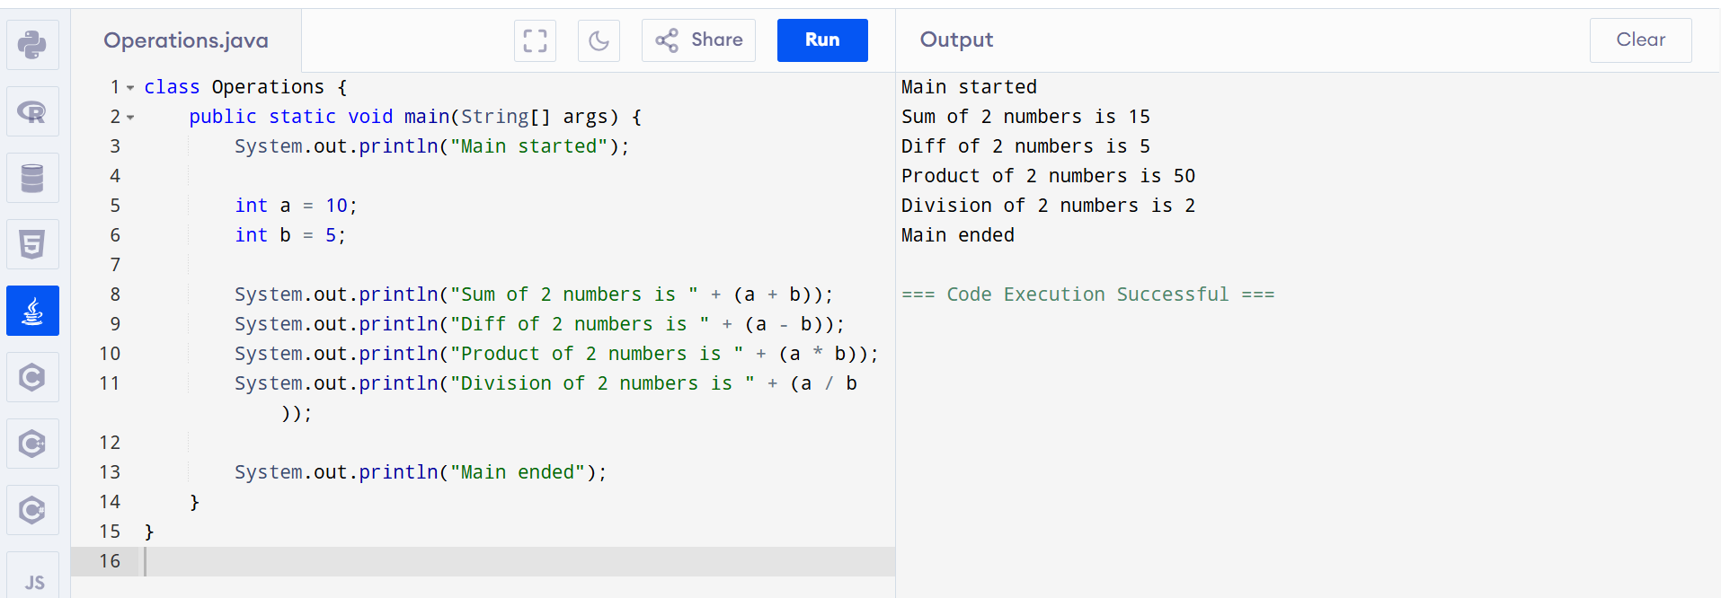

Task 006:

class GreaterNumber {

public static void main(String[] args) {

int a = 10;

int b = 5;

String result = (a > b) ? "a is greater" : "b is greater";

System.out.println(result);

}

}

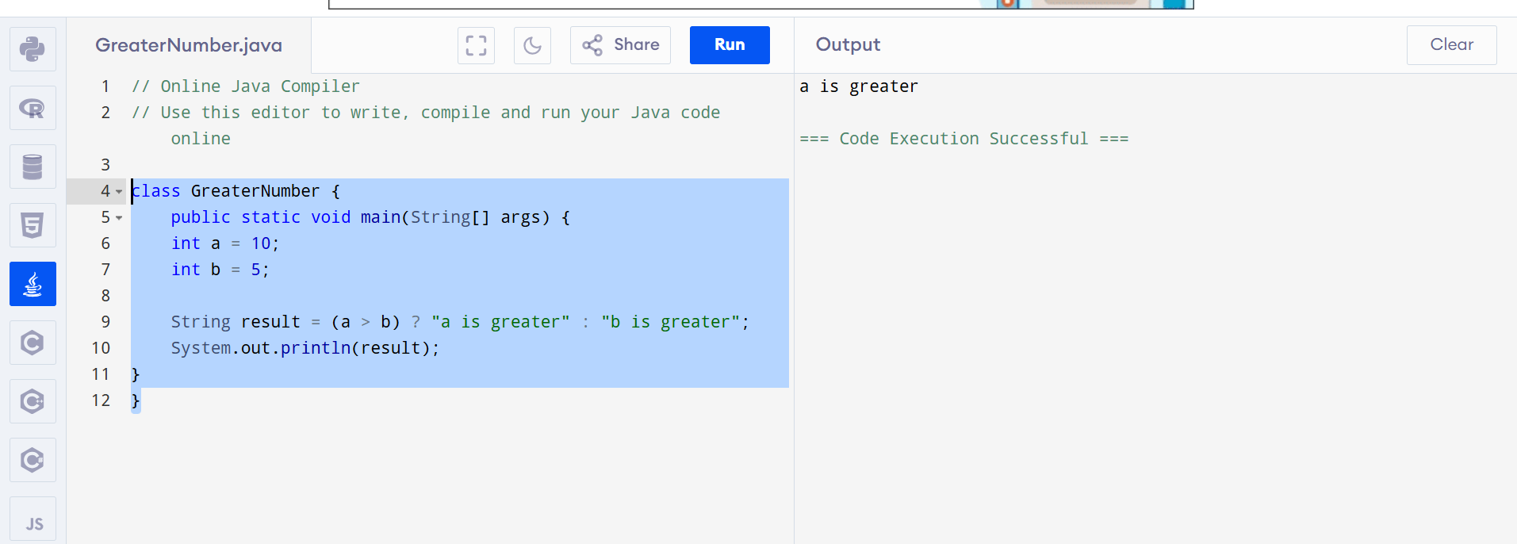

Task 007:

import java.util.Scanner;

class SimpleInput {

public static void main(String[] args) {

Scanner sc = new Scanner(System.in);

System.out.println("Enter something:");

String input = sc.nextLine();

System.out.println("You entered: " + input);

sc.close();

}

}

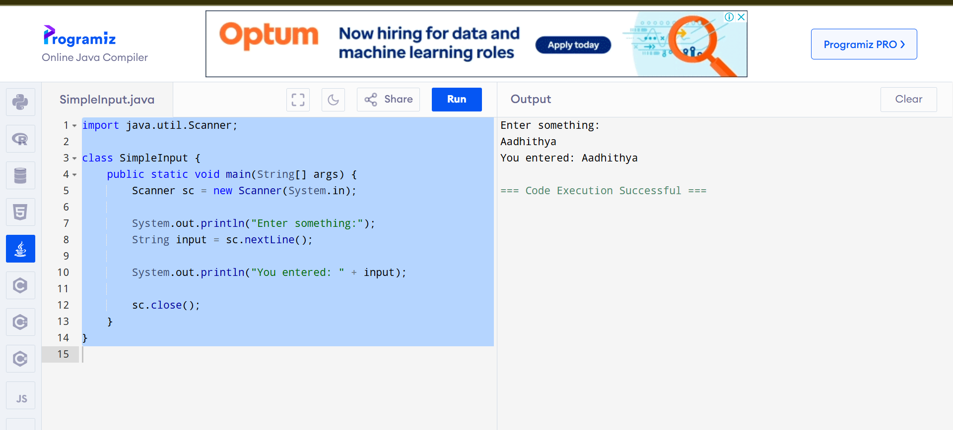

import java.util.Scanner;

class LoginDetails {

public static void main(String[] args) {

Scanner sc = new Scanner(System.in);

System.out.print("Id : ");

String id = sc.nextLine();

System.out.print("Pwd: ");

String pwd = sc.nextLine();

System.out.println("\nHi,");

System.out.println("\tYour login id is " + id);

System.out.println("And your pwd is " + pwd);

sc.close();

}

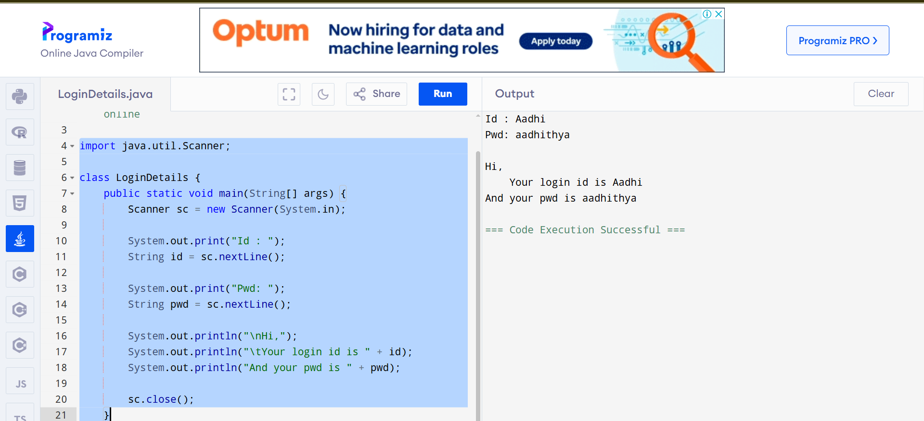

Task008

// Customer class

class Customer {

void accept() {

System.out.println("accept Customer called");

}

void display() {

System.out.println("display Customer called");

}

}

// Test008 class

public class Test008 {

public static void main(String[] args) {

Customer custom = new Customer();

custom.accept();

custom.display();

}

}

Task009

class Test009 {

public static void main(String[] args) {

int a = 20;

int b = 30;

if (a > b) {

System.out.println(a + "a is greater");

} else {

System.out.println(b + "b is greater");

}

}

}

